**Style Guidelines for Final Year Project ReportsDriveNet: Vehicle Trading with Price Prediction**

**Final Year Project Proposal**

**Session 2023-2024**

A 4th Year Student

A project submitted in partial fulfilment of the

COMSATS University Degree

of

BSc. (Hons.)BS in Computer Science / Software Engineering (CUI)



Department of Computer Science

COMSATS University Islamabad, Lahore Campus

03 October 2023

**Project Registration**

|  |  |  |  |  |  |  |  |
| --- | --- | --- | --- | --- | --- | --- | --- |
| Project ID (for office use) | | |  | | | | |
| Type of project | | | [✅] Traditional [ ] Industrial [ ] Continuing | | | | |
| Nature of project | | | [✅] **D**evelopment [ ] **R**esearch [ ] **R**&**D** | | | | |
| Area of specialisation | | |  | | | | |
| **Project Group Members** | | | | | | | |
| Sr.# | Reg. # | Student Name | | CGPA | Email ID | Phone # | Signature |
| (i) | Group Leader  FA20-BSE-051 | Muhammad Zohaib | | 3.22 | [FA20-BSE-051@CUILAHORE.EDU.PK](mailto:FA20-BSE-051@CUILAHORE.EDU.PK) | 0315 5326400 |  |
| (ii) | FA20-BSE-064 | Hafiz Kunwar M. Ahmad | | 3.28 | [FA20-BSE-064@CUILAHORE.EDU.PK](mailto:FA20-BSE-064@CUILAHORE.EDU.PK) | 0300 7963959 |  |
| (iii) | FA20-BSE-071 | Muhammad Mehroz | | 2.96 | [FA20-BSE-071@CUILAHORE.EDU.PK](mailto:FA20-BSE-071@CUILAHORE.EDU.PK) | 03371602198 |  |
| **Declaration:** FYP group members have cleared all prerequisites courses For FYP-I as per their degree requirements.  For BS(Computer Science)  (CSC241 Object Oriented Programming, CSC291 Software Engineering Concepts, CSC371 Database Systems-I, HUM102 Report Writing Skills)  For BS(Software Engineering)  (CSC241 Object Oriented Programming, CSE291 Introduction to Software Engineering, CSC371 Database Systems-I , HUM102 Report Writing Skills) | | | | | | | |

**Plagiarism Free Certificate**

This is to certify that, I am __Muhammad Zohaib__ S/D/o _Muhammad Zahid_, group leader of FYP under registration no CIIT/__FA20-BSE-051__/LHR at Computer Science Department, COMSATS Institute of Information Technology, Lahore. I declare that my FYP proposal is checked by my supervisor and the similarity index is 3% that is less than 20%, an acceptable limit by HEC. Report is attached herewith as Appendix A.



Date: 2 October 2023 Name of Group Leader: Muhammad Zohaib Signature: _____________

Name of Supervisor: Ms. Sana Maqbool Co-Supervisor (if any):____________________

Designation: Lecturer Designation: _____________________

Signature: *SanaMaqbool* Signature: _____________________

Table of Contents

Project Abstract 4

1 Introduction 5

1.1 Problem Statement 5

2 Success Criterion 5

3 Related work 6

4 Project Rationale 6

4.1 Aims and Objectives 7

4.1.1 Objectives 7

4.2 Scope of the Project 7

5 Proposed Methodology and Architecture 7

5.1 Methodology 7

5.1.1 Requirements Gathering and test cases 8

5.1.2 Design and Planning 8

5.1.3 Technology Stack Selection: 8

5.1.4 Development: 8

5.1.5 Machine Learning Model Development 8

5.1.6 Community System Integration 8

5.1.7 User Testing 8

5.2 System Architecture 9

6 Individual Tasks 9

7 Gantt Chart 11

8 Tools and Technologies 11

9 References 12

Project Abstract

In the digital age, vehicle selling is evolving with technology and changing consumer preferences. The 'DriveNet' project introduces a unique website to address the challenges faced by vehicle sellers and buyers. It employs ML to accurately estimate vehicle values and fosters a vibrant community for car enthusiasts. Key objectives include an 80% accuracy rate for price predictions, user base growth, 75% user satisfaction, and a fair feedback system. DriveNet focuses exclusively on vehicles, offering an intuitive interface, ML price predictions, and a built-in community for user engagement and guidance. The project aims to simplify the vehicle selling process, enrich user experience, and connect enthusiasts. Methodology includes requirements gathering, design, technology stack selection, development, machine learning, community integration, and rigorous user testing. The architecture of the system is client-server with object-oriented architecture style.

# Introduction

In today's fast-paced digital age, the art of selling vehicles is undergoing a profound transformation. This shift is driven by the fusion of technology and evolving consumer tastes. When someone decides to sell/buy a car, they often face questions like "Which is the best platform for selling or purchasing of vehicles “or "What's the right price?" or "How can I connect with fellow car enthusiasts?" or "Is there someone for guiding me?”. Often sellers regret selling their vehicle for less price while buyers regret paying higher price than the actual price of the vehicle. This project, called " DriveNet " aims to provide a solution to all these questions and issues. We're creating a unique website that can estimate a car's value and also lets people chat with others who share their love for cars. Additionally, it keeps you in the loop about vehicle-related events by integrating the vehicle community. It actually performs two crucial functions. Firstly, it harnesses the power of advanced technology to estimate a vehicle's worth accurately, empowering sellers with knowledge and confidence. Secondly, it fosters connections among car enthusiasts, offering them a place to engage in vibrant discussions, share their passion, and access information on upcoming automotive events in their local communities.

The primary objective of this project is to simplify the car-selling process, enriching it not only in terms of financial gain but also by enhancing the enjoyment and knowledge of everyone involved. We invite you to be a part of our mission as we strive to reshape and elevate the experience of selling vehicles in the modern digital era.

## Problem Statement

Today's digital age, the re-selling of old vehicles through online marketplaces has become increasingly popular. However, both sellers and buyers face several challenges in this process. One of the most significant challenges is determining the optimal selling price for used items. Sellers often struggle to set a competitive price that reflects the item's true value, while buyers aim to make informed purchasing decisions based on fair market prices. While the vehicle owners often seek opportunities to connect with like-minded individuals who share a passion for automobiles. And buyers are looking for people for guidance about the right vehicle and its price of course. However, finding relevant events and establishing connections within the automotive community can be challenging.

# Success Criterion

The success of the " DriveNet " project will be determined by various key performance indicators. Firstly**,** the accuracy of our price prediction model is paramount, with a target *accuracy rate of 80 percent*. This will ensure that our users can rely on the platform to provide pricing estimates that closely match real market values for a wide range of vehicles.

Secondly**,** we aim to attract and retain a substantial user base. The vehicle community is also a crucial part of our system which helps when AI fails at any point. Vehicle enthusiasts in our vehicle community can guide about pricing and sell-purchase of vehicles. So, we aim that *7 out of 10 vehicle enthusiasts find our system captivating*. User satisfaction is another critical measure of success. Ongoing *user feedback* surveys should consistently reveal a satisfaction rate of at least *75 percent***.** reflecting that users find the platform intuitive, informative, and enjoyable to use.

*Finally***,** as the system somehow relates to the honesty of seller while entering correct details during ad creation, so we also aim to have a feedback and problem reporting system to maintain fair prediction of price. If seller added wrong information, visitors can report it, and we (admin) can block/disable either account or respective ad of the seller.

# Related work

There are some (but not many) related applications exists in Pakistan (broadly speaking Asia) but none of them integrates the AI price prediction for vehicles or dedicated vehicle community for the vehicle enthusiasts (people who can help both sellers and buyers). However, we have found some datasets on Kaggle to train our price prediction model. And, some of them were scraped from the existing related applications. One of these datasets can be found at [1]

Following are some applications that are somehow related to our proposed system.

|  |  |  |
| --- | --- | --- |
| **Application Name** | **Weakness** | **Proposed Solution** |
| OLX [2] | * Focuses on selling and purchasing of all general items * Too basic UI | * Focus on the vehicle category only * Introduction of Intuitive and user-friendly UI |
| PAKWHEELS [3] | * Doesn’t have any feature about guidance about fair price * Have vehicle inspection fees and need to hire inspectors * Doesn’t have user engagement features | * Price prediction using AI and Machine Learning. * Creation of built-in vehicle community to guide about price and vehicle specifications * Community posts and Events in the community |

# Project Rationale

In the modern world, owning a vehicle has become an important part of lives. Some of the people already have them, while some are looking to buy one. Some are looking to upgrade to upper models by *selling their old/used vehicles* while some are *looking**for their first car*. We have some platforms for that but have nobody to guide about selling-purchasing of vehicles and their fair prices. “DriveNet” introduces a web-based application to list the used vehicles (cars and bikes) and an AI based price prediction system to tell seller captivating and fair price for the ad (being listed). And, it also helps the buyers to know the predicted price, even if seller refused to put the predicted price.

There are many *vehicle enthusiasts* in our country who are always willing to find like-minded people in the community. For example, *vehicle modification* lovers often look for the best modification for their cars or bikes by looking at other people’s modifications. Our system provides such a platform with vehicle community. Buyers can join community to make relations with other vehicle enthusiasts and get guidance or vehicle inspection, *without paying inspection fees* on other platforms. Other systems have paid vehicle inspections systems for that, but we replace this with a better and free solution.

## Aims and Objectives

The goal of the project is to provide a platform for selling and purchasing of used/preowned vehicles, including guidance from both ML (price prediction) and built-in vehicle community.

* Develop accurate vehicle price prediction tool with optimal accuracy of 80%.
* Simplify vehicle selling by connecting sellers and buyers.
* Implementing feedback and problem reporting system to ensure reliability of the system.
* Create a community for vehicle enthusiasts to showcase projects, chat, and seek advice.
* Improve the vehicle selling and buying experience for profitability and enjoyment.

## Scope of the Project

The scope of the "DriveNet" project encompasses the development of a web-based platform for vehicle trading, which includes:

* **Price Prediction Module:** Developing a machine learning/deep learning-based module for vehicle price prediction for use convenience.
* **Vehicle Management Module:** For creating, editing, removing and sharing of vehicle advertisement.
* **Vehicle Viewer Module:** A module for viewing the on-sale vehicles and its details.
* **Chat Module:** A communication system to contact vehicle’s seller or vehicle enthusiasts in the community of website.
* **Vehicle Community Module:** A built-in community for vehicle enthusiasts for making friendships with each other to seek guidance and help from specialists. And for posts and events listings related to vehicles and automotive enthusiasts
* **UI Module:** User-friendly interfaces for both sellers and buyers.
* **Problem Reporting Module:** Feedback and reporting mechanisms for fair pricing.
* **Admin Module:** A panel for admin for handling reported issues, user management (blocking/unblocking), and posting the events in the community.

# Proposed Methodology and Architecture

## Methodology

The methodology for DriveNet web application structured around a systematic and theoretical analysis of the methods applied to this project. The “Waterfall Model” is chosen for DriveNet web application due to its sequential and linear approach, which aligns with our clearly defined requirements and the small, focused team of 3 members. This structured methodology ensures systematic progression, allowing thorough planning and precise implementation throughout the project lifecycle with proper documentation. Following is the methodology we have planned for the project:

### Requirements Gathering and test cases

The project will commence with an in-depth analysis of user requirements and market needs. This phase will involve surveys, user interviews (especially vehicle enthusiasts), and market research to identify the specific points and expectations of vehicle sellers, buyers, and enthusiasts.

### Design and Planning

Based on the gathered requirements, a comprehensive design and planning phase will follow. This will encompass defining the system's features, user interfaces, and technical specifications. Additionally, project milestones and a timeline will be established.

### Technology Stack Selection:

As mentioned earlier, the MERN (MongoDB, Express.js, React, Node.js) stack will be employed for its flexibility and scalability. The selection of additional libraries and tools will also be finalized during this phase.

### Development:

The development phase will involve the creation of the web-based application and AI-based price prediction system. We will work on both the frontend (React) and backend (Node.js and Express.js) components in parallel, ensuring seamless integration.

### Machine Learning Model Development

For the price prediction system, machine learning models will be developed using Python and its libraries like scikit-learn and TensorFlow. These models will be trained on historical vehicle data to provide accurate price estimates. The dataset will be used from Kaggle, or may be scrapped in case it’s not enough.

### Community System Integration

The community system, including forums, event listings, and user profiles, will be integrated into the platform. User engagement features like notifications and messaging will be developed.

### User Testing

Continuous testing will occur throughout development to identify and address issues promptly and after the development integration and user testing will be performed. The accuracy of ML modal will be tested.

## System Architecture

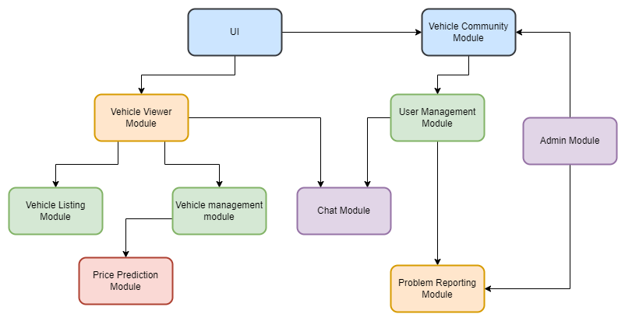The architecture of the system will be modular and scalable. We plan to use Client Server Architecture with the introduction of Object-Oriented Architecture Style. Following is the basic architecture of our system:

# Individual Tasks

|  |  |  |
| --- | --- | --- |
| **Team Member** | **Activity** | **Tentative Date** |
| Hafiz Kunwar Muhammad Ahmed | Requirement Elicitation | 5 October 2023 – 18 October 2023 |
| Muhammad Mehroz | Requirement Analysis | 19 October 2023 – 25 October 2023 |
| Muhammad Zohaib | Database Design | 3 November 2023 – 8 November 2023 |
| Hafiz Kunwar Muhammad Ahmed | UI/UX design | 9 November 2023 – November 13 2023 |
| Muhammad Mehroz | Price Prediction Module Architecture | 15November 2023 – 19 December 2023 |
| Muhammad Zohaib | Chat Module Architecture | 15 November 2023 – 19 December 2023 |
| Hafiz Kunwar Muhammad Ahmed | Chat Module Architecture | 15 November 2023 – 19 December 2023 |
| Muhammad Mehroz | Admin Module Architecture | 20 December 2023 – 29 December 2023 |
| Muhammad Zohaib | Authentication Module Architecture | 1 January 2024 – 12 January 2024 |
| Muhammad Mehroz | Price Prediction Module Coding | 15 January 2024 – 11 March 2024 |
| Muhammad Zohaib | Chat Module Coding | 15 January 2024 – 11 March 2024 |
| Hafiz Kunwar Muhammad Ahmed | Admin Module Coding | 15 January 2024 – 11 March 2024 |
| Muhammad Mehroz | Add Module Coding | 12 March 2024 – 25 March 2024 |
| Muhammad Zohaib | Authentication Module | 26 March 2024 – 25 April 2024 |
| Hafiz Kunwar Muhammad Ahmed | Module Testing | 26 April 2024 – 10 May 2024 |
| Muhammad Mehroz | Integration Testing | 13 May 2024 – 17 May 2024 |
| Muhammad Zohaib | System Testing | 20 May 2024 – 24 May 2024 |

# Gantt Chart

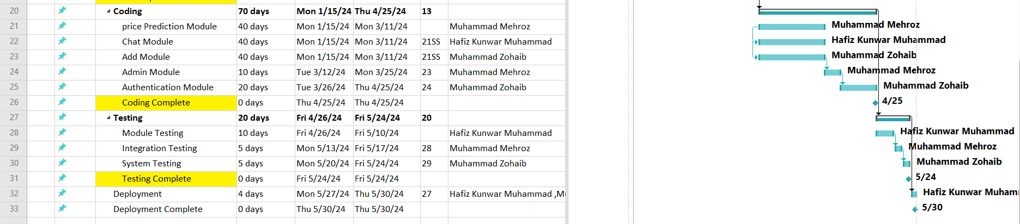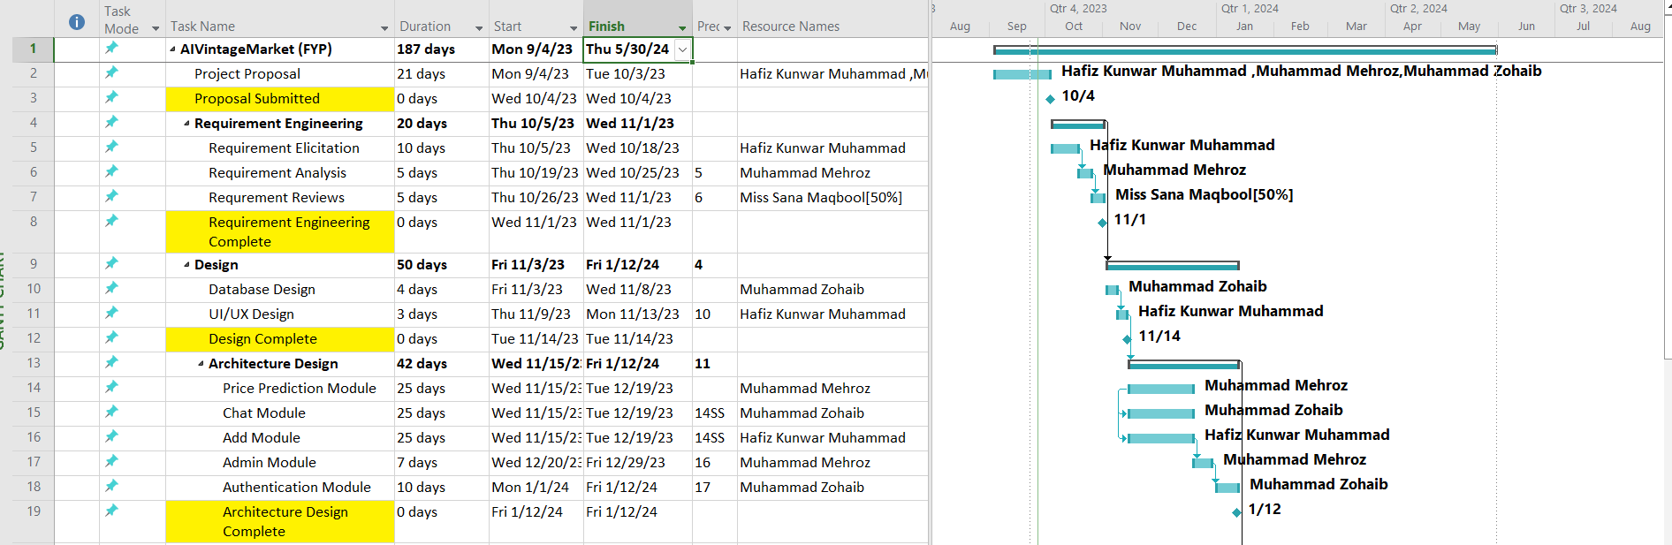

# Tools and Technologies

|  |  |
| --- | --- |
| **Code Editors** | VS Code, Jupyter Notebook |
| **Web Development Frameworks** | React & Express (MERN), Bootstrap |
| **Programming Languages** | Javascript, Python |
| **Machine Learning Libraries** | Scikit learn, Tensorflow, Pandas, Numpy , Matplotlib |
| **Database** | Mongodb |
| **Server** | Localhost (React Router), Postman |

# References

|  |  |
| --- | --- |
| [1] | A. ZAHID, “Pakistan's Largest PakWheels Automobiles Listings,” Kaggle, 2021. [Online]. Available: https://www.kaggle.com/datasets/asimzahid/pakistans-largest-pakwheels-automobiles-listings/data. [Accessed 25 September 2023]. |
| [2] | Prosus, “OLX PAKISTAN,” 2016. [Online]. Available: https://www.olx.com.pk/. [Accessed 2023 September 25]. |
| [3] | S. S. Munj, “Pakwheels,” [Online]. Available: https://www.pakwheels.com/. [Accessed 25 September 2023]. |

Appendix A

